**Business Requirements Document for Al-Wahiyyan Portal**

**Document Synopsis**

This document details the functional and non-functional business requirements related to Al-Wahiyyan Portal.

**Document Details**

|  |  |  |  |
| --- | --- | --- | --- |
| **Author:** | Mehdi Shahjahan | **Version Number:** | Version: 1.0 |
| **Release Date:** | 02/03/18 | **Status** | Released |
| **Audience:** | Al-Wahiyyan Management Team |  |  |

**ALL PRINTED COPIES ARE UNCONTROLLED**

Contents

References 3

Revision History 4

1 Introduction 5

1.1 Purpose 5

1.2 Intended audience 5

1.3 Overview 5

1.4 Scope 5

1.5 Assumptions 6

2 Functional Requirements 7

3 Non-Functional Requirements 9

4 Business Uses Cases 10

4.1 Actors 10

4.2 Use Case Diagram 11

4.3 Use Cases 13

5 Appendix 17

# References

The following table lists meetings with the client, referenced sites and documents that were used in creation of this document:

|  |  |  |
| --- | --- | --- |
| **#** | **Name** | **Comments** |
| 1 | Client meeting on 17th Feb 2018 @Yanabee Al- Jinan campus |  |
| 2 | http://www.alhudapk.com/ |  |
| 3 |  |  |
| 4 |  |  |
| 5 |  |  |

# Revision History

The following table lists the revision history of the document

| **Version Number** | **Date Updated** | **Revision Author** | **Brief Description of Changes** |
| --- | --- | --- | --- |
| 1.0 | 02/3/2018 | Mehdi Shahjahan | Original draft |
|  |  |  |  |

# Introduction

## Purpose

The purpose of this document is to detail the functional and non-functional requirements of the Al-Wahiyyan portal as requested by the client. Thus it is intended to serve as a reference document to consolidate all the requirements.

## Intended audience

Client is the primary audience of this document. It shall also be used by the design and the testing teams to carry out their respective work.

## Overview

The current scope of this document covers the functionality as required to be provided on Al-Wahiyyan portal.

## Scope

### In-Scope

The scope of the work of this project includes the following:

1. Student Profile Management.
2. Login Management.
3. Course Enrollment Management.
4. Course Management.
5. Upload and Download Management.
6. Email Notification Management.
7. Search Engine.
8. Content Management.
9. Reporting.

### Out of Scope

The scope of the work does not include the following:

1. Capturing site activities of anonymous and registered users.
2. Payments capability.

## Assumptions

1. Guest users can use the portal and have access to all the contents of the site such as books listing, courses and audio lectures.
2. Only registered users can upload the assignments.
3. A student can enroll to multiple courses at the same time.
4. The system will not perform any kind of verification with regards to the official/government related IDs.

# Functional Requirements

|  |  |
| --- | --- |
| Ref # | Requirement |
| REQ-1 | The homepage will contain the following sections:   * Main menus(Navigation bar) * Logo * Upcoming events(scrolling) * Main page containing “About us, Mission statement, Vision” etc. * Links to Social Media(if available) |
| REQ-2 | The following main menus will be available on the home page:   * Home * Courses * Online Lectures * Books Download * Submissions * FAQs * Contact Us * Signup * Sign in |
| REQ-3 | The Sign in link will navigate the user to login page, wherein he/she provides the login credentials. |
| REQ-4 | The Signup link will navigate the user to create his/her profile |
| REQ-4 | The “Contact Us” link will navigate the user to a page containing the contact details including the address of the program |
| REQ-5 | The FAQs link will navigate the user to a page where frequently asked questions with answers are provided. |
| REQ-6 | The Submissions menu will navigate the user to a page where he/she can upload the assignments. |
| REQ-7 | The “Books Download” menu when clicked will display a dynamic listing of books. |
| REQ-8 | The displayed list of books upon clicking on will allows the user to download the book. |
| REQ-9 | The “Online lectures” menu will contain the following topics:   * Tafsir * Hadith   Each of the above topic contains its respective dynamic listing. |
| REQ-10 | Each item under “Online lectures” namely, Tafsir and Hadith when clicked will display a dynamic listing of lectures respectively. |
| REQ-11 | Upon clicking a selected audio lecture, the user is redirected to mixcloud.com site. |
| REQ-12 | Upon clicking a selected video lecture, the user will be redirected to Al-Wahiyyan YouTube channel. |
| REQ-13 | The “Courses” menu will contain the following items:   * Tajweed * Tafsir * Hadith(Sahih Bukhari) |
| REQ-14 | Each item under “Courses” namely Tajweed, Tafsir and Hadith when clicked will display a dynamic listing of courses respectively. |
| REQ-15 | The student will get a reminder in the form of an email notification 3 days prior to the commencement of a course. |

# Non-Functional Requirements

|  |  |
| --- | --- |
| Ref # | Requirement |
| NFR-1 | The web content of the site must be in English language. |
| NFR-2 | The portal design must cater to responsive user interface i.e. it must be compatible on web browser, mobile and tablets. |
| NFR-3 | The portal must be compatible to work on the following browsers (The versions of the browsers will be determined later).   * Internet Explorer * Chrome * Safari |
| NFR-4 | The following file formats must be supported to upload books   * pdf * docx * jpeg * png |
| NFR-5 | The following file format must be supported to upload for audio lectures   * mp3 |
| NFR-6 | The following file format must be supported to download students in bulk   * excel |

# Business Uses Cases

This section specifies the actors involved in using the system and the description of each business use case included in scope.

## Actors

The users that interact with the system are as follows:

* Guest user
* Student
* Administrator

## Use Case Diagram

The following diagrams indicates the use cases and all their direct relationships with each other and their associations with actors

### Student Use Case Diagram

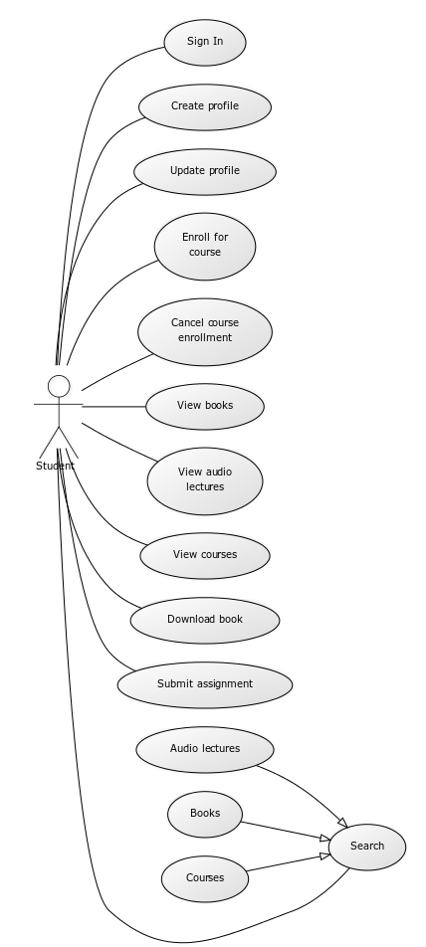

### Administrator Use Case Diagram

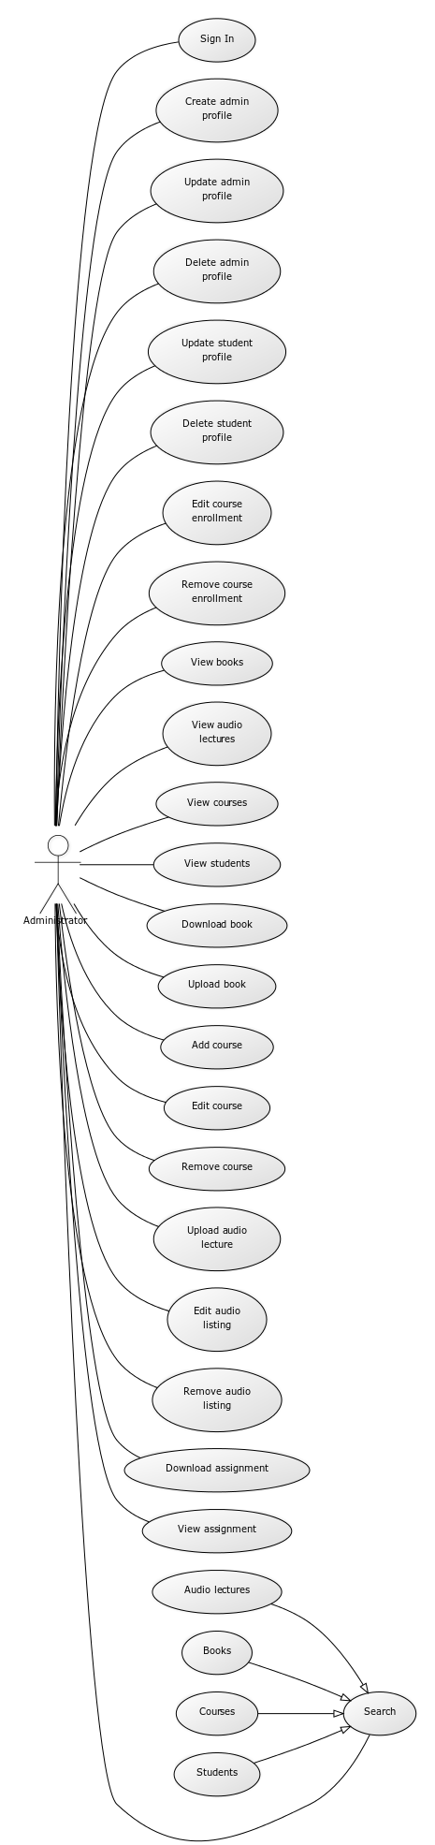

## Use Cases

|  |  |  |
| --- | --- | --- |
| Role | Use Case | Use Case Description |
| Student | Create profile | The system will allows a guest user to create his/her profile. |
| Update profile | The system allows a registered user to update his/her profile. |
| Sign In | The system allows a registered user to login using his/her credentials. |
| Enroll for course | The system allows a registered user or a guest user to enroll for available courses. |
| Cancel course enrollment | The system allows a registered user or a guest user to cancel his/her earlier enrollment of the courses. |
| View list of books | The system allows a registered user or a guest user to view the available books. |
| View list of courses | The system allows a registered user or a guest user to view the available courses. |
| View list of audio lectures | The system allows a registered user or a guest user to view the available audio lectures. |
| Download a book | The system allows an existing user or a guest user to download a book. |
| Submit assignment (Upload) | The system allows a registered user to upload his/her assignments in the predefined format. |
| Search audio lectures | The system allows a registered user or a guest user to search audio lectures based on a predefined filters such as, surah name, hadith title etc. |
| Search books | The system allows a registered user or a guest user to search books based on a predefined filters such as book title, author etc. |
| Search courses | The system allows a registered user or a guest user to search courses based on a predefined filters such as surah name, tajweed topic etc. |
|  |  |
| Administrator | Sign In | The system allows the administrator to login using his/her credentials. |
| Create admin profile | The system allows the primary administrator to create a profile of a secondary administrator. |
| Update admin profile | The system allows the primary administrator to update the profile of a secondary administrator. |
| Delete admin profile | The system allows the primary administrator to delete the profile of a secondary administrator. |
| Edit course enrollment | The system allows the administrator to update the course enrollment of a student. |
| Edit course enrollment | The system allows the administrator to remove the course enrollment of a student. |
| Update student profile | The system allows the administrator to update the profile of a student. |
| Delete student profile | The system allows the administrator to delete the profile of a student. |
| Add course | The system allows the administrator to add a course under a predefined heading. |
| Remove course | The system allows the administrator to remove a course from a predefined heading. |
| Edit course | The system allows the administrator to edit the details of the course from a predefined heading. |
| View courses | The system allows the administrator to view courses on the portal. |
| View students | The system allows the administrator to view registered users on the portal. |
| Upload book | The system allows the administrator to upload a book on the portal. |
| Remove book listing | The system allows the administrator to remove a book from the portal. |
| Download book | The system allows the administrator to download a book from the portal. |
| Remove audio listing | The system allows the administrator to remove an audio lectures from the portal. |
| Search students | The system allows the administrator to search registered students on a predefined filters such as, last name, email-ID etc. |
| Search audio lectures | The system allows the administrator to search audio lectures based on a predefined filters such as, surah name, hadith title etc. |
| Search books | The system allows a registered user or a guest user to search books based on a predefined filters such as book title, author etc. |
| Search courses | The system allows the administrator to search courses based on a predefined filters such as surah name, tajweed topic etc. |
| Download assignment | The system allows the administrator to download assignments as submitted by the students. |
| View assignments | The system allows the administrator to view the assignments submitted by the students. |
| Remove audio listing | The system allows the administrator to remove the audio listing from the portal. |
| Edit audio listing | The system allows the administrator to edit the audio listing on the portal. |
| Upload audio lecture | The system allows the administrator to upload the audio listing on the mixcloud.com site and store the reference url of the uploaded audio on the portal system. |

# Appendix

None